***Donaldson***

John James Donaldson

(Parents – William Leverton Donaldson and Margaret

Born – 31st July, 1853, Bloomsbury, London, England

Baptism – 16th November, 1853, St George, Bloomsbury, Camden, England

Died – Unknown

Occupation – Clerk and long prison record

Married – 27th June, 1878, Egerton House, Semaphore, South Australia (bk115/pg1143)

(groom – 24, single, William Leverton Donaldson) (bride – 18, single, Richard Blacker)

Rosa Margaret Elizabeth Blackler

Born – 23rd September, 1860, Port Adelaide, South Australia (bk15/pg450)

Died – 21st February, 1916, Armadale, Melbourne, Victoria

Aged – 55 years

Abode – 1882, Lipson street, Adelaide;

Buried – Brighton Cemetery

Last abode – 23 Wynnestay road, Armadale

1. John Archibald Donaldson

Born – 11th May, 1879, Semaphore, South Australia (bk221/pg90)

Died – 29th November, 1879, Kent Town, South Australia (bk98/pg334)

Aged – 6 months

1. Edgar Leverton Donaldson

Born – 11th May, 1879, Semaphore, South Australia (bk221/pg90)

Died – 20th November, 1879, Kent Town, South Australia (bk98/pg264)

Aged – 6 months

1. Rose Winifred Donaldson

Born – 6th June, 1880, Thebarton, South Australia (bk243/pg124)

Died – 4th March, 1881, Exeter, South Australia (bk109/pg276)

Aged – 9 months

1. Philip Tennent Donaldson

Born – 2nd February, 1882, Port Adelaide, South Australia (bk275/pg299)

Died – 23rd December, 1882, Port Adelaide, South Australia (bk124/pg214)

Aged – 11 months

1. Ida Donaldson

Born – 2nd February, 1882, Port Adelaide, South Australia (bk275/pg298)

Died – 29th January, 1886, Exeter, South Australia (bk152/pg328)

Aged – 4 years

***Newspaper clippings***

***The Age, Melbourne, Victoria, dated Monday 14th June, 1875***

*Northumberland, s., 2342 for London. Passengers – saloon – John James Donaldson*

***Herald, Melbourne, Victoria, dated Saturday 17th July, 1875***

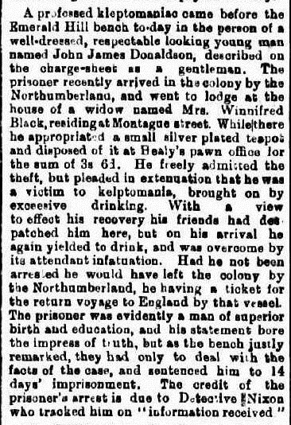

***South Australian Register, dated Thursday, 11th July, 1878***

**MARRIAGE**

**DONALDSON-BLACKER –** on the 27th June at the residence of the bride’s mother, Egerton House, Semaphore, by the Rev. M. Dick, Mr. John J. Donaldson, youngest son of the late William Leverton Donaldson of Southampton-street, London, W.C., to Rosa Margaret Elizabeth, only child of Mrs R. Blackler.

***South Australian Register, dated Saturday 22nd November, 1879***

**DEATHS**

**DONALDSON** – On the 21st November, at College road, Kent Town, after a few hours illness, Edgar Leverton, youngest and beloved twin son of John and Rosa Donaldson, aged six months and ten days.

***Evening Journal, dated Saturday, 29th November, 1879***

**DEATHS**

**DONALDSON** - on the 29th November, at College road, Kent Town, suddenly, John Archibald, eldest twin son of John and Rosa Donaldson, aged six months and eighteen days. Survived his brother eight days.

***Evening Journal, dated Friday 4th March, 1881***

**DEATH**

**DONALDSON** – on the 4th March, at Exeter, of dysentery, caused by teething, Rosa Winifred, beloved infant daughter of John and Rosa Donaldson, aged nine months.

***South Australian Register, dated Friday 17th March, 1882***

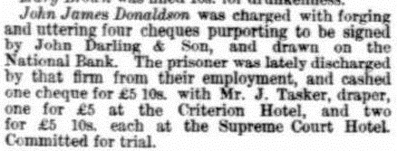

***The Express and Telegraph, SA, dated Tuesday 4th April, 1882***

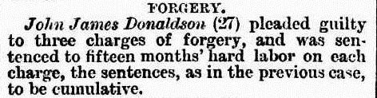

***Evening Journal, dated Wednesday 27th December, 1882***

**DEATH**

**DONALDSON** – on the 23rd December, at Lipson-street, Port Adelaide, Phillip Tennant, the beloved eldest twin child of John and Rosa Donaldson, of consumption, aged ten months and two weeks.

***South Australian Register, SA, dated Monday 3rd March, 1884***

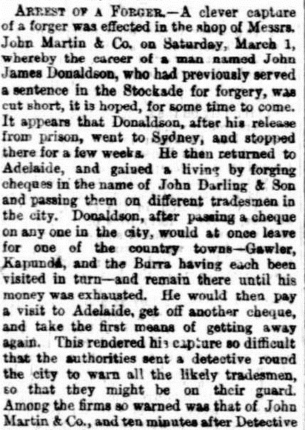 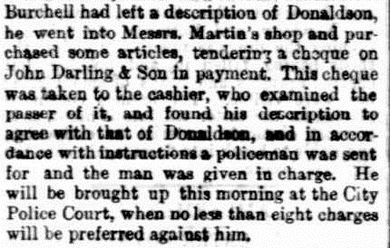

***The Mercury, Tasmania, dated Wednesday 2nd April, 1884***

John James Donaldson, for forgery, has been sentenced to eight years imprisonment.

***Mount Alexander Mail, Victoria, dated Wednesday 2nd April, 1884***

John James Donaldson was sentenced today to eight years imprisonment, with hard labour, being convicted on several cases of forgery. The Chief Justice commented severely on the reprehensible conduct of some persons who wrote him a letter, setting forth the delinquencies of the prisoner, stating that if His Honour did his duty he would punish prisoner severely. His Honour felt disposed to bring the writer of the letter before the court for punishment for attempting to bias the judge.

***Evening Journal, dated Monday 1st February, 1886***

**DEATHS**

**DONALDSON** – On the 29th January, at Exeter, after three weeks illness, Ida, the beloved and only child of Mrs. Donaldson, 25, Rundle street, aged 4 years.

***The Express and Telegraph, SA, dated Saturday 7th December, 1889***

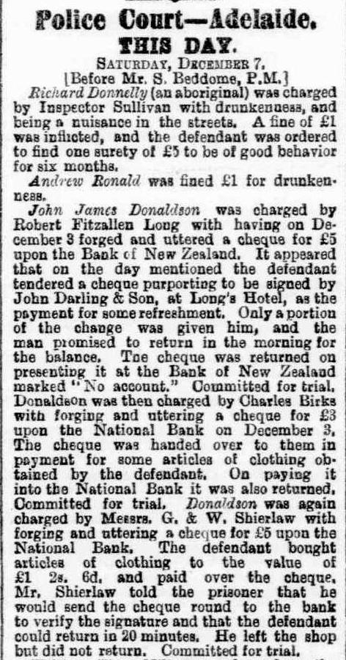

***Adelaide Observer, dated Saturday 22nd February, 1890***

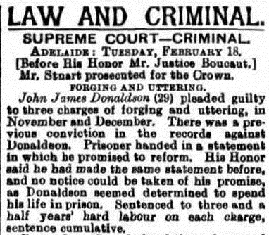

***The Argus, Victoria, dated Tuesday 22nd February, 1916***

**DEATH**

**DONALDSON** – on the 21st February, at private hospital, Armadale, Mrs Rosa Donaldson, aged 55 years.

**FUNERAL NOTICE –**

**DONALDSON** – Friends of the late Mrs. Rosa Donaldson are respectfully informed that her remains will be interred in the Brighton Cemetery.

The Funeral will leave her late residence, 23 Wynnestay road, Armadale, THIS DAY (Tuesday), at 11am.

***English Census***

***1861, Middlesex, England***

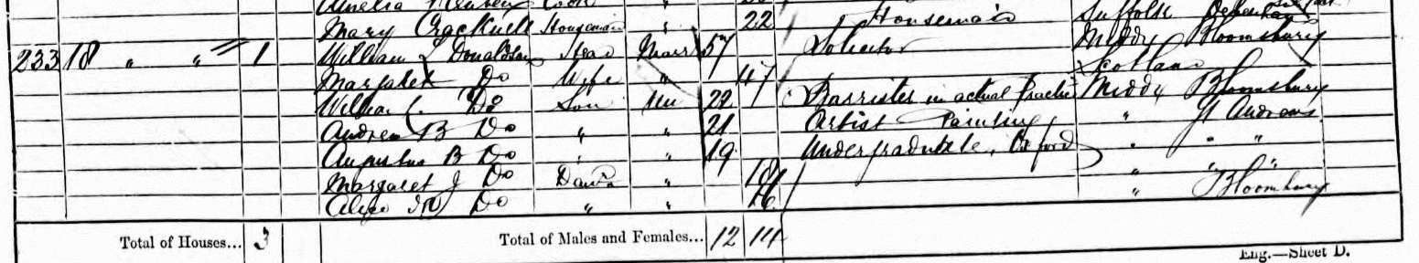

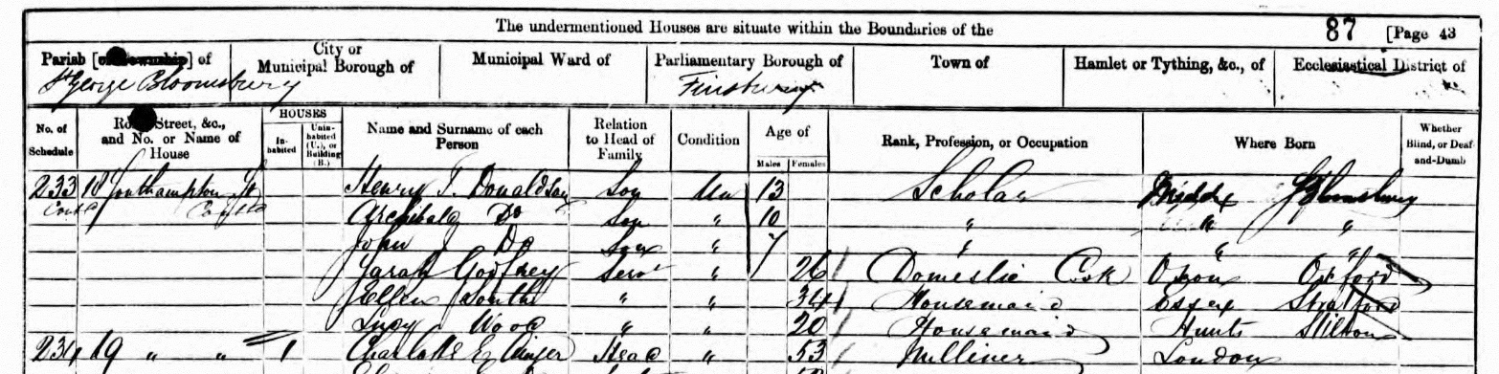

*Reads:*

*William L. Donaldson, 57 years, Head, occupation - Solicitor*

*Margaret Donaldson, 47 years, wife*

*William Donaldson, 22 years, son, occupation – Barrister in actual practice*

*Andrew B. Donaldson, 21 years, son, occupation – Artist, painting*

*Augustus B. Donaldson, 19 years, son, occupation – Undergraduate, Oxford*

*Margaret J. Donaldson, 18 years, daughter*

*Alice Donaldson, 16 years, daughter*

*Henry T. Donaldson, 13 years, son,*

*Archibald Donaldson, 10 years, son*

*John J. Donaldson, 7 years, son*

*Sarah Gorfrey, Servant, 26 years, Domestic Cook*

*Ellen South, servant, 34 years, Housemaid*

*Lucy Wood, servant, 20 years, Housemaid*

***1871, Lancing, Sussex, England***

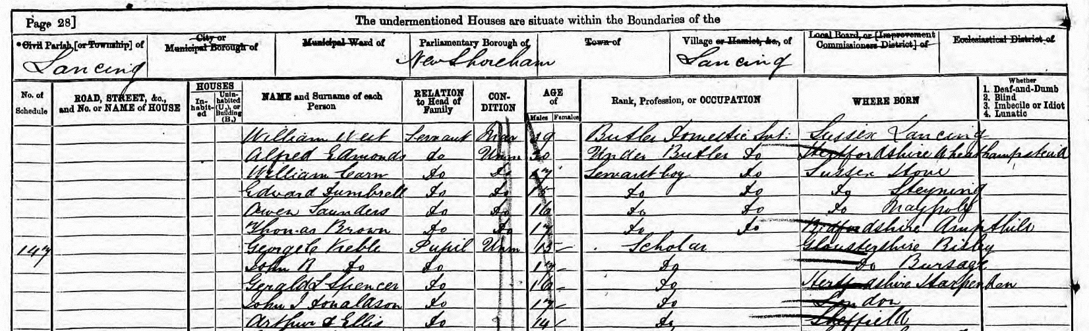

*Reads*

*John J Donaldson, aged 17 years, pupil, born – London, England.*

***Victoria, Police Gazette, 1875***

Gaol – Melbourne

Name – Donaldson, John James, 3474

Where tired – Sandridge

When – 17th July, 1875

Offence – larceny

Sentence – 14 days

Native of – England

Trade – Clerk

Born – 1858

Height & c. – 5 8

Complexion – frest

Hair – brown

Eyes – grey

Nose –

Mouth –

Chin –

Remarks and previous convictions – No previous conviction.

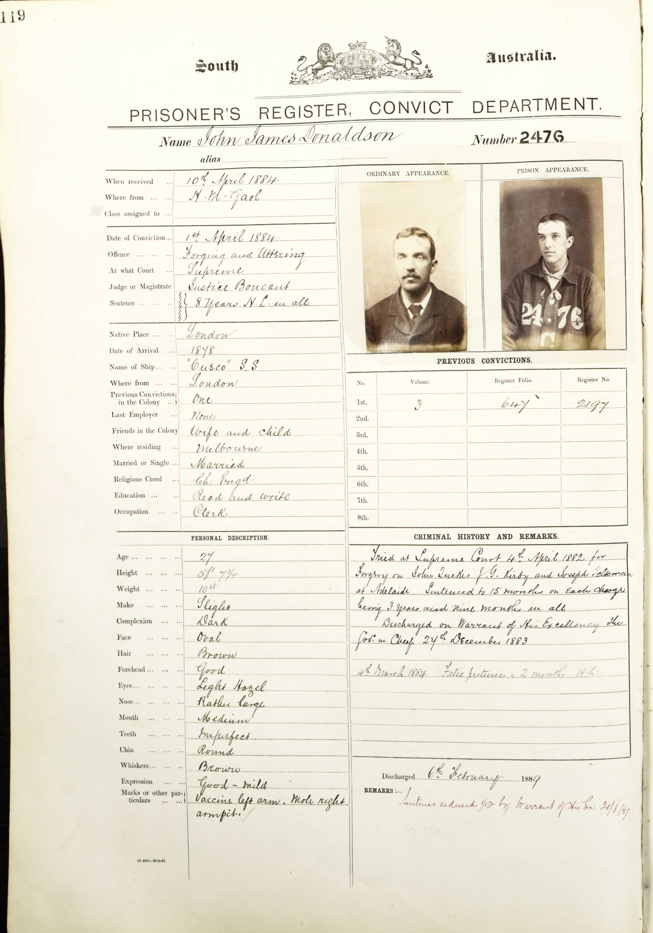

South Australia Yatala Labour Prison, 1884

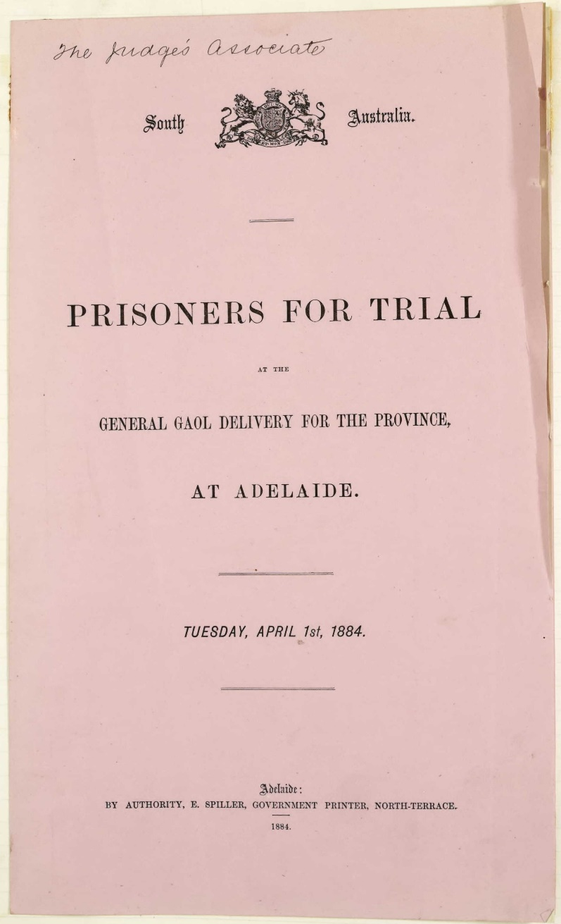

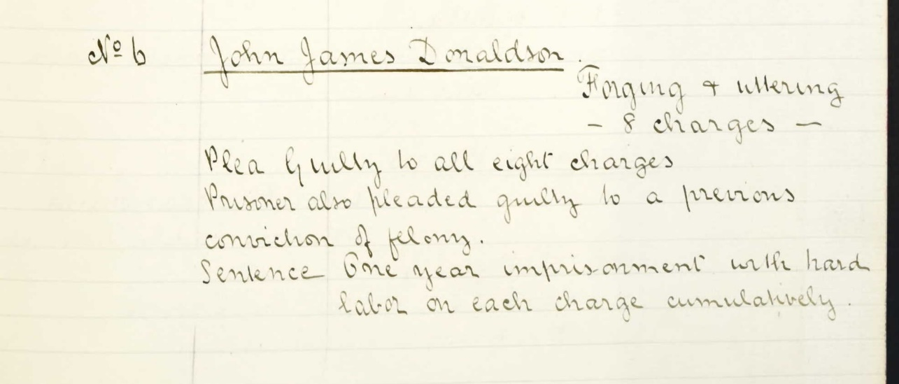

South Australia, Supreme Court Criminal record books – 1884

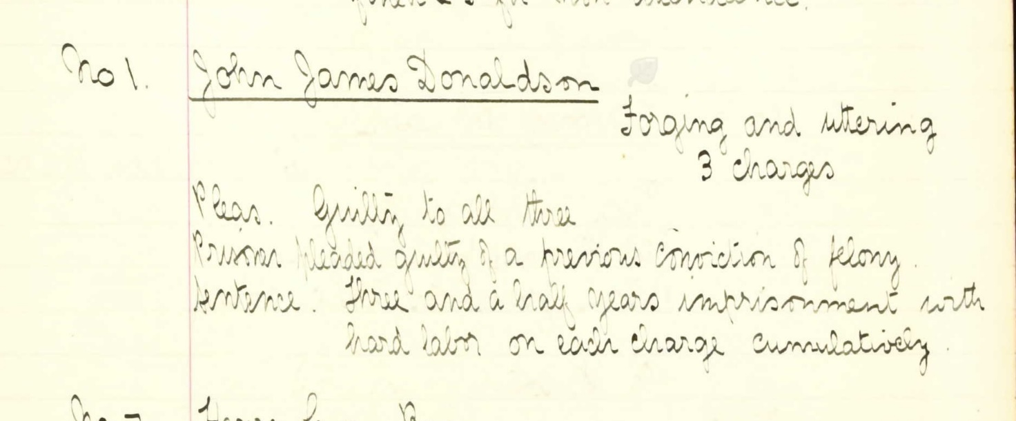

South Australia, Supreme Court Criminal record books – 18th February, 1890

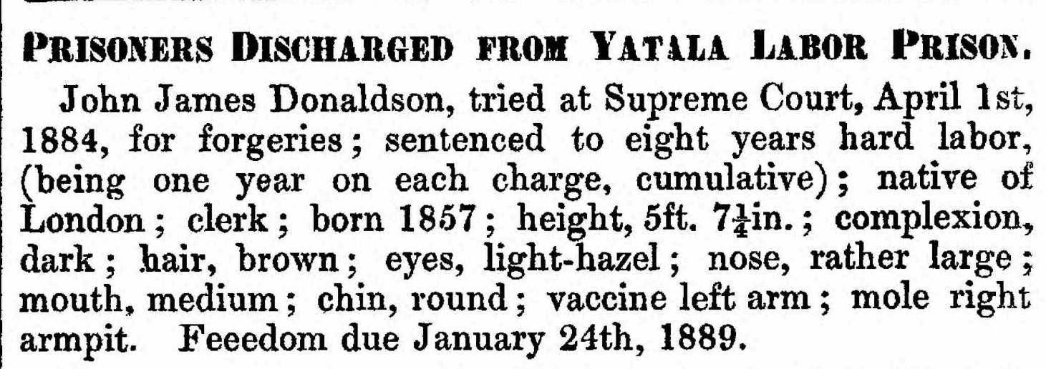

South Australia, Police Gazettes, 1889

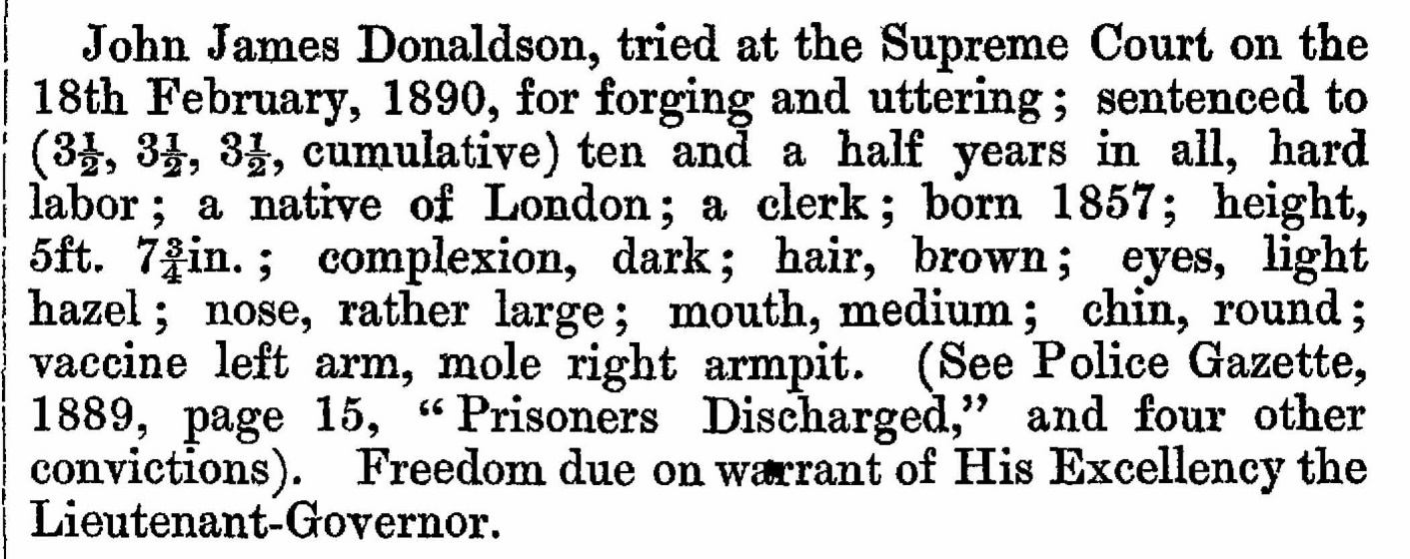

South Australia Police Gazette, 1894